Nucleophilic addition reactions are expected to be in _______.
A. $C=C$
B. $C≡C$
C. $C=O$
D. $C≡N$
E. Both C and D
F. Both A and B
ANSWER: E

Acetone reacts with HCN to form a cyanohydrin. It is an example of
A. Electrophilic addition
B. Nucleophilic addition
C. Electrophilic substitution
D. Nucleophilic substitution
ANSWER: B
Meta formaldehyde is formed when _____ undergo polymerization in acidic medium.
A. Acetaldehyde
B. Formaldehyde
C. Propionaldehyde
D. Butyraldehyde
ANSWER: B
Paraformaldehyde is formed when _____ undergo polymerization in acidic medium.
A. Acetaldehyde
B. Formaldehyde
C. Propionaldehyde
D. Butyraldehyde
ANSWER: A
It is the structure of Meta formaldehyde.

A.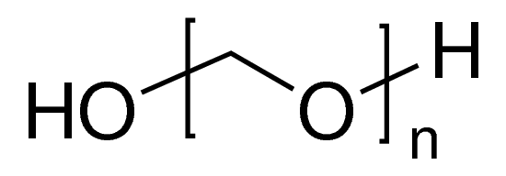
B. 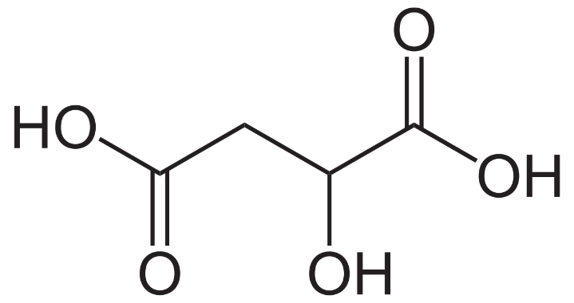
C. 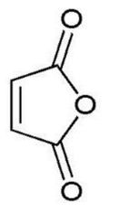
D. 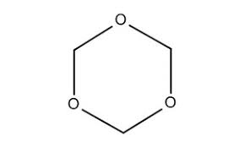
ANSWER: D

Which of the following reaction with carbonyl compound yield hydrazone?
A. Phenyl hydrazine
B. Hydrazine
C. 2,4-DNPH
D. All of these
ANSWER: D
Reaction of acetaldehyde with ammonium hydroxide yields
A. Oxime
B. Hydrazone
C. Dinitrophenyl hydrazone
D. None of these
ANSWER: A
2,4-DNPH is
A. Dinitritophenol hydrazine
B. Dinitritophenyl hydrazone
C. Dinitrophenyhl hydrazone
D. Dinitrophenyl hydrazine
ANSWER: D
Which of the following compound will form on reduction of aldehyde?
A. Primary alcohol
B. Secondary alcohol
C. Tertiary alcohol
D. All of these
ANSWER: A
Ketone reduction will give
A. Primary alcohol
B. Secondary alcohol
C. Tertiary alcohol
D. All of these
ANSWER: B
Which of the following catalyst is used in catalytic reduction?
A. Ni
B. Pt
C. Pd
D. All of these
ANSWER: D

Which of the following is used in reduction of aldehyde and ketone?
A. $K_{2}Cr_{2}O_{7}/H_{2}SO_{4}$
B. $H_{2}SO_{4}$
C. $NaBH_{4}$
D. All of these
ANSWER: C
Which of the following alcohol will be formed when Grignard reagent react with Ketone?
A. Primary
B. Secondary
C. Tertiary
D. All of these
ANSWER: C
Secondary alcohol can be formed by reacting Grignard reagent with ____.
A. Methanal
B. Ethanal
C. Propanone
D. All of these
ANSWER: B

Complete the following reaction.
$$C_{2}H_{5}MgI+HCHO \underset{→}{ }$$A. $H_{2}C(OH)C_{2}H_{5}$
B. $H_{2}CHC\left(OH\right)CH_{3}$
C. $H_{2}CHC\left(OH\right)CH_{3}$
D. ${\left(H_{3}C\right)}_{2}C(OH)(CH_{3})$
ANSWER: A

